**Area and perimeter of a square**

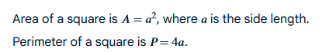

**Area and perimeter of a rectangle**

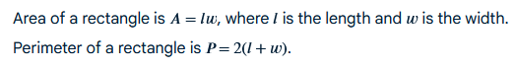

**Area and perimeter of a triangle**

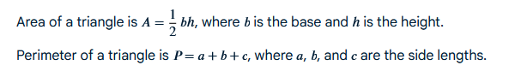

**Area and circumference of a circle**

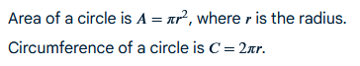

**Surface area and volume of a cube**

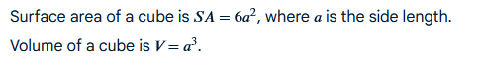

**Surface area and volume of a rectangular prism**

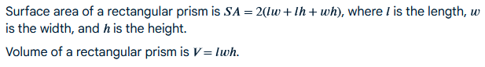

**Surface area and volume of a cylinder**

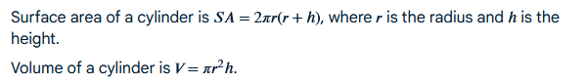

**Surface area and volume of a cone**

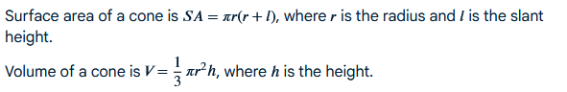

<https://xgeometry.com/formulas/isosceles-triangle>

| **Shape** | **units** | | **Figure** |
| --- | --- | --- | --- |
| Square | **Area:**  a2  **Parameter:** 4 a | |  |
| Rectangle | **Area:** l x b  **Parameter:** 2 (l + b) | |  |
| Circle | **Area:**  r2  **Parameter:** 2 $π$ r | |  |
| Isosceles Triangle | **Area:** (b × h) / 2  **Parameter:** 2a + b | |  |
| Scalen Triangle |  | |  |
| Equilateral Triangle | **Area:**  **Parameter:** 3 a | |  |
| Right Angle Triangle | **Area:** ½ b x h  **Parameter:** b + hypotenuse + h | |  |
| Rhombus | **Parameter:** 4 x side | |  |
| Parallelogram | **Area:** b x h  **Parameter:** 2 (l + b) | |  |
| Trapezium | **Area:** ½ h (a+c)  **Parameter:** a + b + c + d | |  |
|  |  | |  |

